Steps :

1. Login to your Jira Account
2. Click on Create Icon on the top

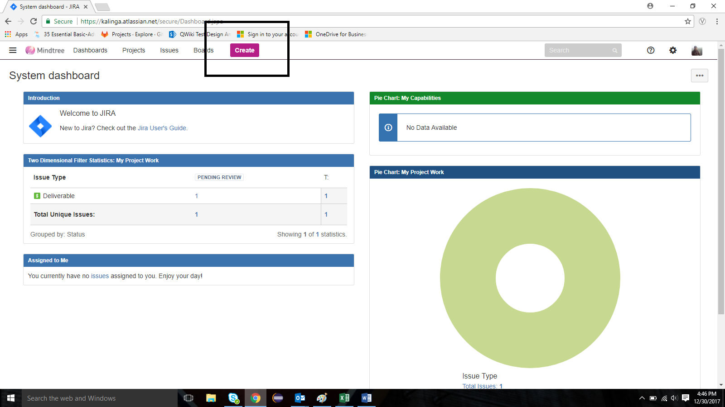

1. Give the values for the fields based on the below screenshot

Project : Select your project name

Issue Type : Epic ( Feature)

Epic Name : Name of your Epic

Summary : Name of your Epic

Reporter : Me

Rest all fields as it is.

Click on Create

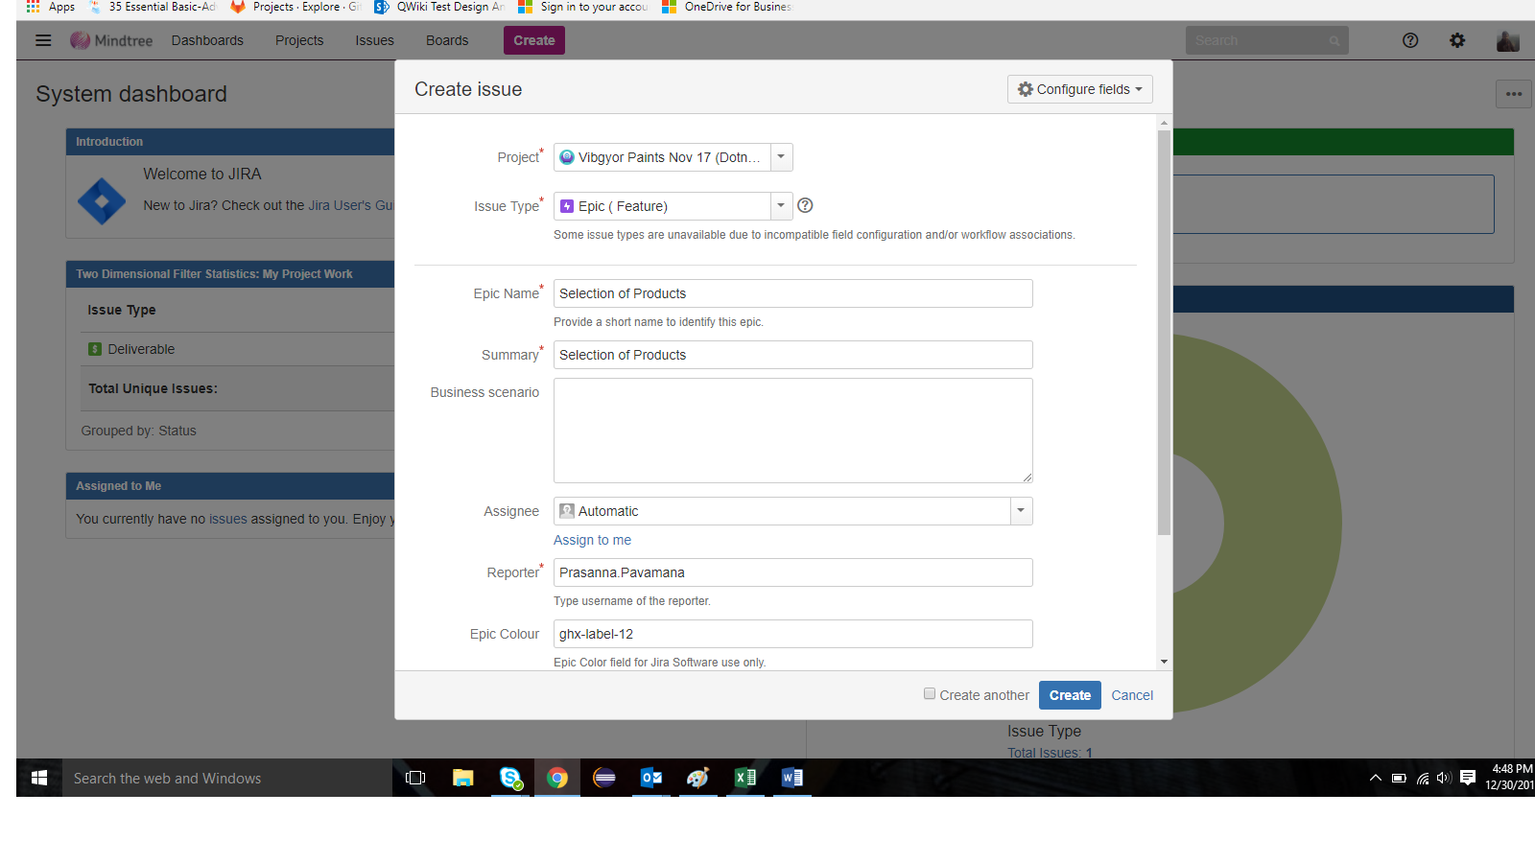

1. Add an Issue to the Epic.

In the Epic page click on the “+” mark under Issues

Note: The following screenshot already has 2 issues created. When you are doing for the first time you will have 0 issues.

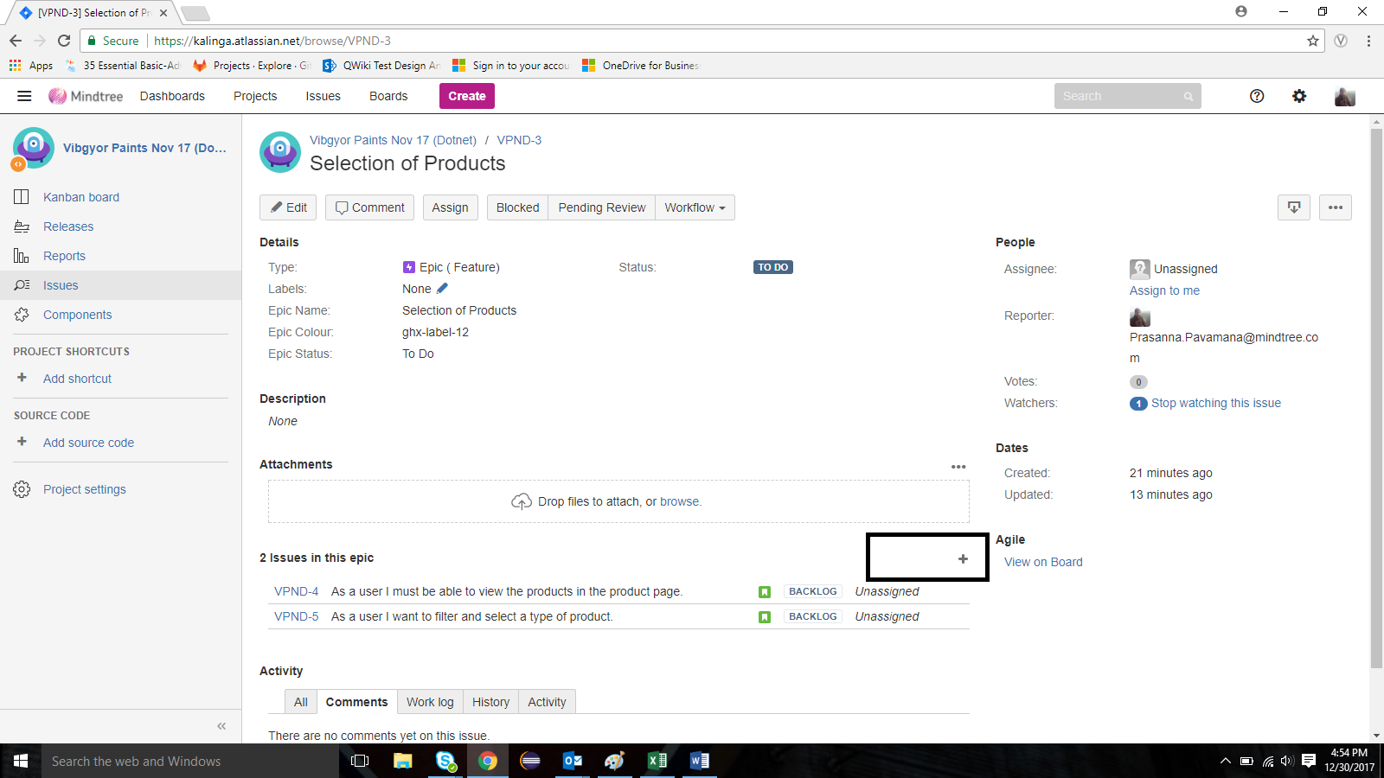

1. Creating user stories under an epic

Project name : Select Your Project

Issue Type : Story

Summary : Enter the Story Name

Reporter : me

Acceptance Criteria: The Acceptance Criteria Text.

Rest all fields as it is.

Click on Create.

Note : Repeat steps 4 and 5 for all the stories under one epic.

